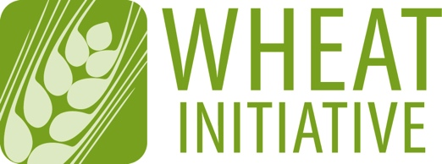
Coordinating global research for wheat

EXPERT WORKING GROUP MEMBERSHIP APPLICATION FORM
Please return your completed form to wheat.initiative@julius-kuehn.de and copy brian.beres@canada.ca

NAME OF EXPERT WORKING GROUP
Wheat Agronomy – A cross-disciplinary systems approach to identify and remove factors responsible for regional yield gaps

EXPECTATIONS FOR EWG MEMBERS
- Participate in EWG meetings and ongoing discussions
- Contribute to the activities of the EWG
- Representation from wheat stakeholder groups is also critical
- Expertise in the following topics
- Agronomy
- Cropping systems & integrated crop management systems research, including digital agriculture
- Wheat
- Cross-disciplinary approaches to wheat systems research, which may include interfaces with livestock production systems.
- While crop and soil agronomists may lead the EWG, membership from cross-disciplines is critical ie. physiologists, crop modellers/remote sensing/digital agriculture (big data) scientists, entomologists, soil microbiologists, wheat breeders, weed ecologists, plant pathologists, economists, policy analysts, and social scientists.

1 - CANDIDATE DETAILS
First Name
Last Name
Wheat Initiative
Website Username*
Position
Country
Institution/Company
Email

2 - PROFESSIONAL ACTIVITIES
Research Activities
Other Activities

3 - PUBLICATIONS RELEVANT TO THE EWG TOPIC

4 - OTHER TYPES OF PRODUCTIONS

5 - ADDITIONAL INFORMATION (in particular, reasons why you would like to be a member of the EWG and what specific expertise or relevant experience you could contribute to its development)

