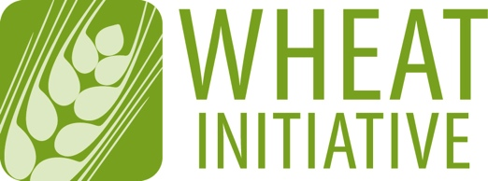
Coordinating global research for wheat

ANNEX 2 (April 2016 update)
EXPERT WORKING GROUP MEMBERSHIP APPLICATION FORM
Please return your completed form to wheat.initiative@inra.fr (maximum 4 pages)

NAME OF EXPERT WORKING GROUP
Wheat phenotyping to support wheat improvement

EXPECTATIONS FOR EWG MEMBERS
The EWG brings together a team of experts to provide direction for future developments in wheat phenotyping. EWG members should meet the following criteria:
- Participate in all EWG meetings
- Contribute to the activities of the EWG
- Provide expertise in at least one of the following areas
- phenotyping structural and functional traits in a breeding or academic environment
- phenotyping of crops, particularly cereals
- field phenotyping
- environmental monitoring of microclimate and/or field scale
- ecophysiological modelling for trait dissection
- crop modelling to assess genetic diversity
- development and optimisation of phenotyping technologies
- expertise in supporting disciplines, such as phenotype database development, high content data analysis and modelling or machine vision
- active involvement in major national or international phenotyping consortia and projects
- ability to link user demands with expert knowledge, preferably in phenotyping

1 - CANDIDATE DETAILS
First Name
Last Name
Wheat Initiative
Website Username*
Position
Country
Institution/Company
Email
* If you do not have a website username, please create your personal account on the Wheat Initiative website (www.wheatinitiative.org). It is recommended that you take your username as First Last (e.g. John Smith). Your username will be needed to access a private online workspace for EWG members.

2 - PROFESSIONAL ACTIVITIES
Research Activities
Other Activities

3 - PUBLICATIONS RELEVANT TO THE EWG TOPIC

4 - OTHER TYPES OF PRODUCTIONS

5 - ADDITIONAL INFORMATION (in particular, reasons why you would like to be a member of the EWG and what specific expertise or relevant experience you could contribute to its development)

